

**Mathematics Methods  
YEAR 11**

**Investigation 2 – Transformations of Functions**

**Semester 1 2015**

**Time allowed:** 60 minutes

**Marks Available:** 50 marks

**Materials required:** Writing implements, correction fluid/tape or eraser, ruler, Scientific or CAS calculator

**Instructions:**

1. Write your answers in the spaces provided in this Question/Answer Booklet.
2. **Show all your working clearly**. Your working should be in sufficient detail to allow your answers to be checked readily and for marks to be awarded for reasoning. Incorrect answers given without supporting reasoning cannot be allocated any marks. For any question or part question worth more than two marks, valid working or justification is required to receive full marks. If you repeat an answer to any question, ensure that you cancel the answer you do not wish to have marked.

1. (8 marks)
2. The following functions are transformations of the function with equation.

Match each given function with the correct description of the transformation that was applied to it. Record the corresponding letters in the table provided. [4]  
  
  
 **1**  **A**  was translated down 1 unit  
  
 **2**  **B**  was dilated  
  
 **3**  **C** was translated 1 unit to the left  
  
 **4**  **D** was reflected about the x-axis  
  
 **E** was translated 1 unit to the right  
  
 **F** was reflected about the y-axis



|  |  |  |  |  |
| --- | --- | --- | --- | --- |
| *Equation* | 1 | 2 | 3 | 4 |
| *Description* |  |  |  |  |

**G** was translated up 1 unit



1. Use the correct language to describe the following transformations of. [4]



...............................................................................................................................................................

...............................................................................................................................................................  
  
...............................................................................................................................................................



...............................................................................................................................................................

...............................................................................................................................................................  
  
...............................................................................................................................................................

1. (6 marks)  
     
   Match each of the graphs drawn below with one of the equations provided and record the corresponding letter in the space provided in the table at the end of the question.

|  |  |
| --- | --- |
| I | II |
| III | IV |
| V | VI |

A:  B:  C:  D: 

E:  F:  G:  H: 

I:  J:  K:  L: 

|  |  |  |  |  |  |  |
| --- | --- | --- | --- | --- | --- | --- |
| *Graph* | I | II | III | IV | V | VI |
| *Equation* |  |  |  |  |  |  |

1. (8 marks)

This graph has the equation 

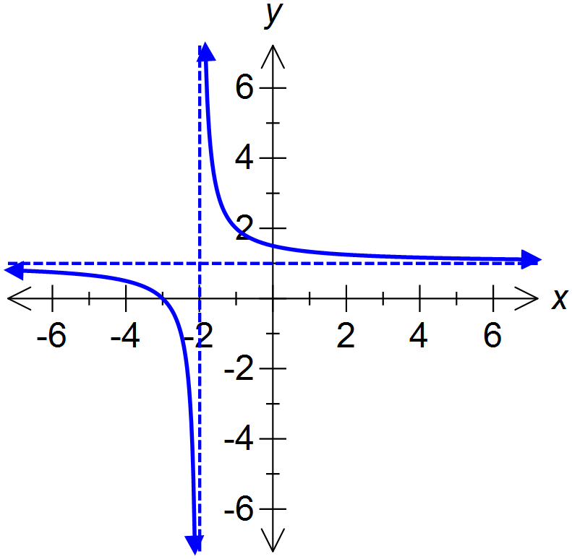

1. What are the dotted lines called and what do they represent? [2]

...............................................................................................................................................................

...............................................................................................................................................................

...............................................................................................................................................................

1. On graph A draw and on graph B draw. [3]



Graph A Graph B

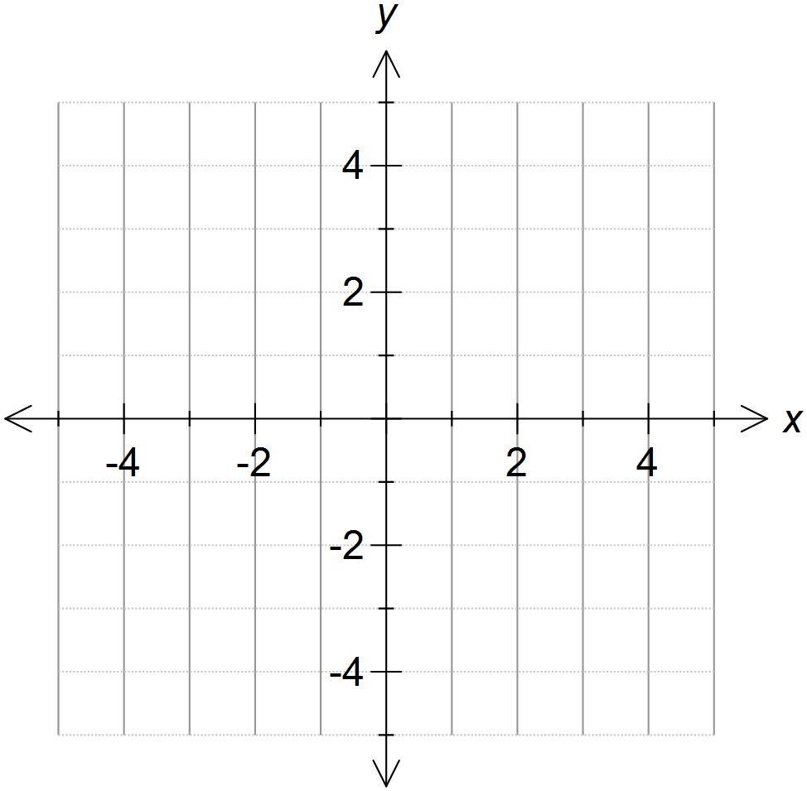

1. Describe three changes when transforming into . [3]



...............................................................................................................................................................

...............................................................................................................................................................

...............................................................................................................................................................

...............................................................................................................................................................

1. (9 marks)  
   Dilations can be made vertically (parallel to the y-axis) or horizontally (parallel to the x-axis).

is a **vertical** dilation of factor **2**. is a **horizontal** dilation of factor **½**.

1. Complete the following: [5]

 is a translation ...................... one unit followed by a ................................. dilation of factor ................

 is the same translation as above, followed by a ................................. dilation of factor ................

1. Write the equation which represents a transformation of , translated 3 units to the left then dilated parallel to the x- axis by factor 3. [2]

...............................................................................................................................................................

1. Some transformations can be described as dilations in either direction. [2]
2. Describeas a vertical dilation.

........................................................................................................................................................

........................................................................................................................................................

1. Describeas a horizontal dilation.



........................................................................................................................................................

........................................................................................................................................................

1. (5 marks)  
   Reflections can be made in the x-axis or in the y-axis.
2. Explain why some graphs appear the same after such a reflection. [2]

.....................................................................................................................................................................

.....................................................................................................................................................................

1. Give an example of a function (ie the equation of a graph) which is unchanged following [2]
2. a reflection in the y-axis ...............................................................................................................
3. a reflection in the x-axis followed by a reflection in the y-axis (ie flipped over both axes in turn)

........................................................................................................................................................

1. Write the equation which represents a transformation of , reflected in the y-axis. [1]

...............................................................................................................................................................

1. (7 marks)  
   Below is a sketch of y = g(x)

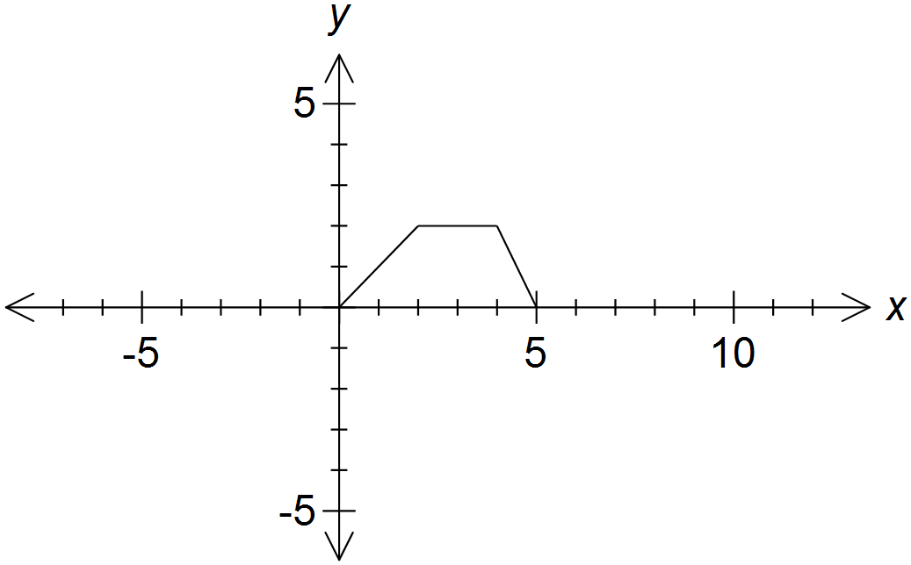

1. Sketch and label clearly, on the same set of axes below, the graphs of: [2]

i. *y* = *g*(*x* – 2) and ii. *y* = *g*()

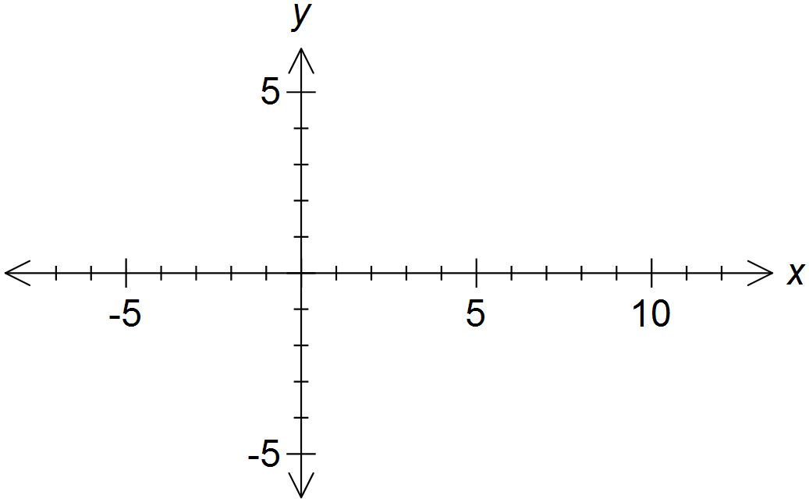

1. Between which two values of x does *g*(*x* – 2) = *g*()? ................ and ................ [2]



1. Describe in terms of *g(x)* the graph of the function shown below: [3]

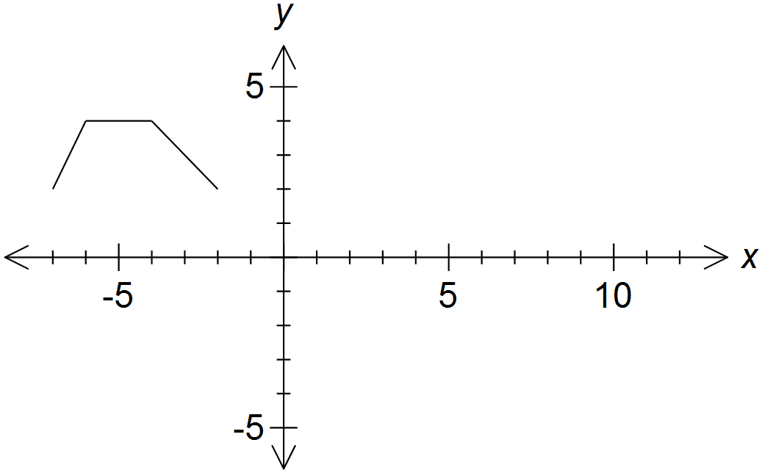

.....................................................................................................................................................................

.....................................................................................................................................................................

.....................................................................................................................................................................

.....................................................................................................................................................................

**End of Validation**